**PRODUCT PLAN - PAY AND GO**

1. **Version 1: Q1 - Q5**

* Version 1 of our product focuses on the beachhead market (Grocery stores in NYC around colleges)
* We develop basic features to enable a scan and pay system.
* We establish good relationships with local grocery stores and track usage data rigorously.

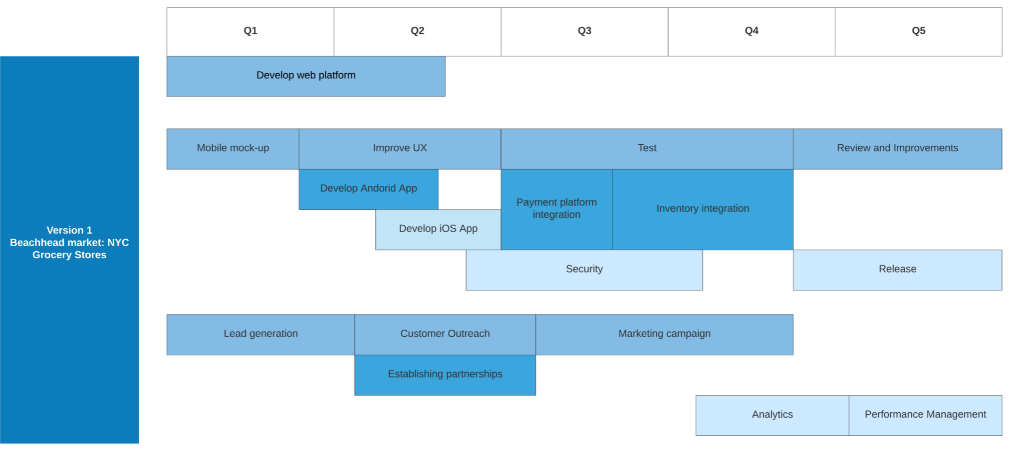

1. **Version 2: Q6 - Q8**

* Upon achieving success in this early market we hope to expand to bookstores around colleges.
* We hope to also expand to other local grocery stores in the city.
* We want to also introduce inventory forecasting algorithms, mock product layouts
* We would also release software improvements, UX improvements and security upgrades.
* We will continuously assess performance and release fixes and upgrades.
* Continue developing partnerships with grocery stores and bookstores.
* Run marketing campaigns in Boston

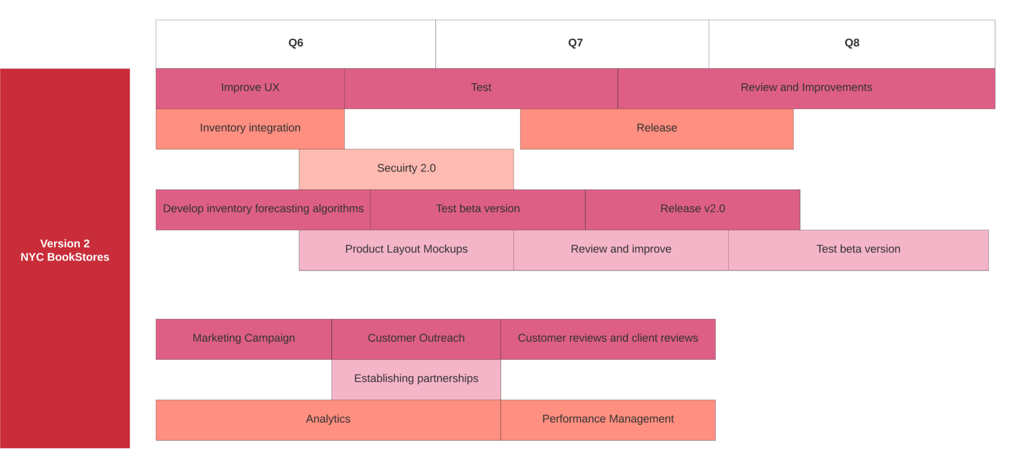

1. **Version 3: Q9 - Q10**

* We will expand to grocery stores and bookstores in Boston.
* We will include deals and promotions features in our apps.
* Release a beta version of expense tracking abilities for our end-users
* We would also release software improvements, UX improvements and security upgrades.
* We will continuously assess performance and release fixes and upgrades.

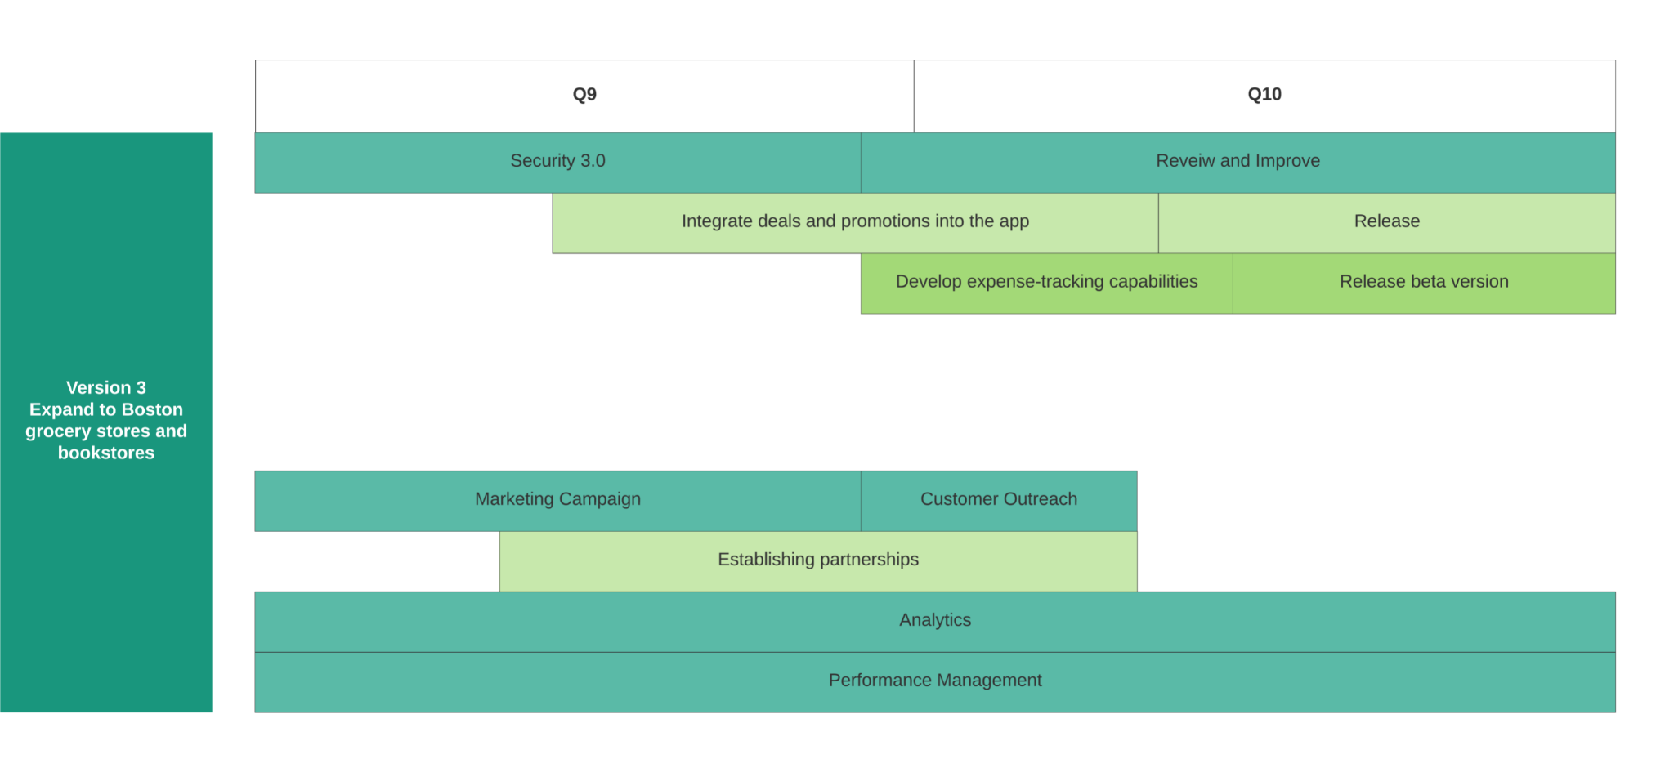

1. **Version 4: Q11 - Q13**

* With version 4, we are shooting for the stars, we want to be the billing solution for all local grocery stores and bookstores.
* Release expense tracking abilities for our end-users
* We would also release software improvements, UX improvements and security upgrades.
* We will continuously assess performance and release fixes and upgrades.
* We track customer reviews and ensure to include new features into our future roadmaps.
* We start developing a new plan to partner with other larger chains in the industry.
* We make our product available to stores around the country.
* At the beginning of Q13, we release our marketing campaign and develop partnerships to become a ubiquitous billing solution.

